Table with user with email,username,roll number,password.

TABLE EMPLOYEE CREATED

CREATE TABLE Employee

(

Rollno int,

username varchar(255),

password varchar(255),

Email varchar(255)

);

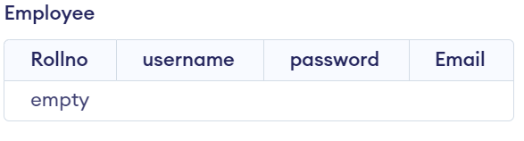

UPDATE,DELETE Queries with user table

INSERT QUERY PERFORMED ON TABLE EMPLOYEE

INSERT INTO Employee

(Rollno,username, password, Email)

VALUES (4, "Jack","jac123","jac.gmail.com" ),

(5, "Jay","j123","j.gmail.com" )

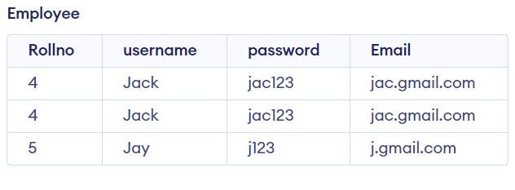

DELETE QUERY PERFORMED ON TABLE EMPLOYEE

DELETE FROM Employee WHERE Rollno=4;

